**Animal Shelter Managment**

**Software Requirements Specification**

**CEN 3031, Fall, 2019**

**Modification history:**

|  |  |  |  |
| --- | --- | --- | --- |
| Version | Date | Who | Comment |
| V0.1 | 9/20/2019 | Seth | Setup SRC on github |
| V0.2 | 9/30/2019 | Seth | Create patients scene and methods |
| V0.3 | pending | multiple | Kennel scenes and methods |

**Team Name:** Tuesday Team 1

**Team Members:**

* Peter Look – pjlookii2220@eagle.fgcu.edu
* Seth Graham – stgraham1506@eagle.fgcu.edu
* Joshua Colicchio – jacolicchil8554@eagle.fgcu.edu
* Joseph Racz – jjracz0621@eagle.fgcu.edu
* Kevin Zink – kmzink1079@eagle.fgcu.edu

**Contents of this Document**

Introduction

* Software to be Produced
* Definition, Acronyms, and Abbreviations

Product Overview

* Assumptions
* Use Case Diagram
* Use Case Descriptions

Specific Requirements

**SECTION 1: Introduction**

Software to be Produced:

The application will allow for workers to check-in new animals as well as adopt them out, edit the animal information, schedule events such as cleanings or vet check-ups, and search for animals by collar ID or species. It should also track the time the animals have been in the shelter. Animals information should include the main species & sub-species.

Definitions, Acronyms, and Abbreviations:

* None

**SECTION 2:** **Product Overview**

Assumptions:

* We are assuming the software will be used at Animal Shelters exclusively.

Use Case Diagram:

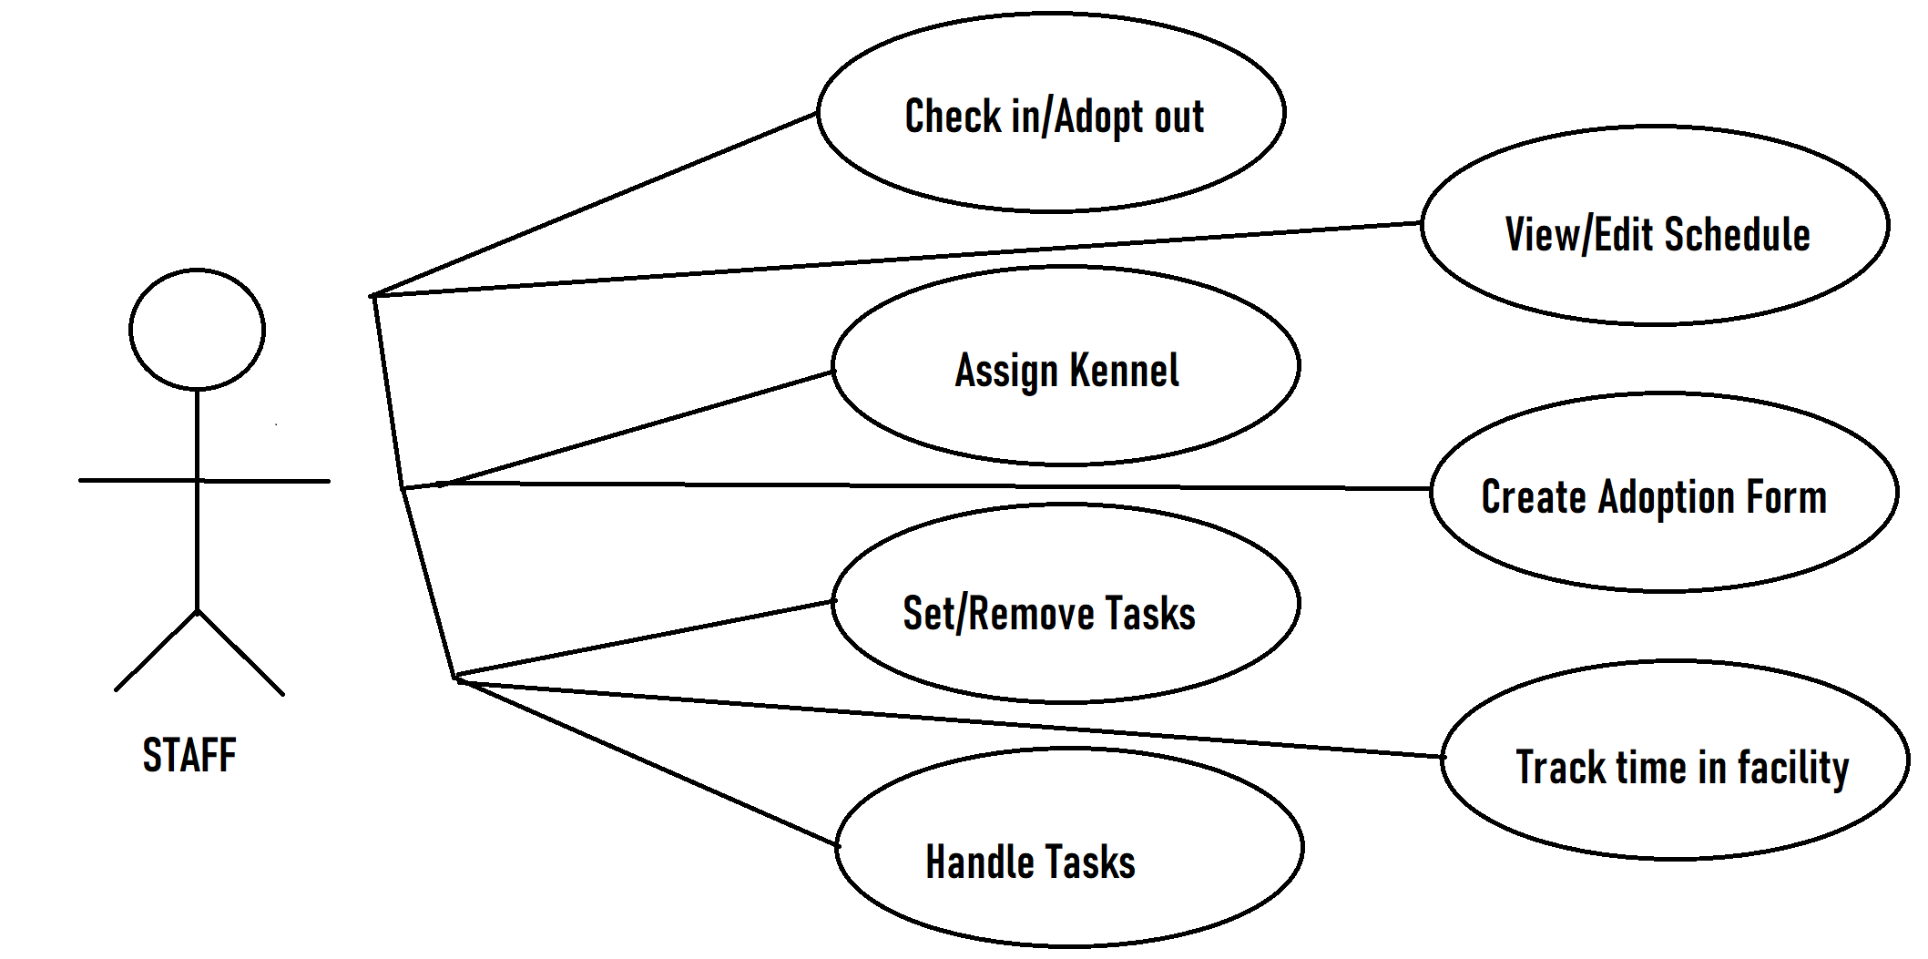Use Case Descriptions:

* Check in/ Adopt out – Staff member will check in and adopt out an animal.
* Assign Kennel – Staff member will assign an animal to an open kennel.
* Set/Remove tasks – Manager will set animal tasks and employees will be assigned to them.
* Handle tasks – Employees will handle and complete tasks.
* View/Edit schedule – Manager will view and edit schedules.
* Create adoption form – Employee will create and complete an adoption form.
* Track time in facility – Software will automatically track and tally time in the facility.

**SECTION 3: Specific Requirements**

**< The following template must be used for each requirement; you should have about 15 requirements total: >**

|  |
| --- |
| **No:** 1-16 |
| **Statement:**  1) The system shall keep track of all animals currently at the shelter.  2) The system shall have an interface for employees to add and remove animals.  3) The system shall allow employees to edit animal information based on the type of animal and  species.  4) The system shall give employees the ability to schedule medical appointments for each  animal.  5) The system shall have an ID system for each animal to keep track of new patients and  previous patients.  6) The system shall allow employees to search for animals using their unique identification  7) The system shall track the length of time each animal has been in the facility.  8) The system shall allow employees to place animals in kennels.  9) The system shall track which kennels are currently occupied by an animal.  10) The system shall display all known information about an animal when viewing the kennel.  11) The software shall track employees.  12) The software shall assign employees tasks.  13) The software shall track all employee tasks.  14) The software shall display which animals are adoptable or not.  15) The software shall keep track of employee hours.  16) The software shall allow employees to login. |

Template created by G. Walton ([GWalton@mail.ucf.edu](mailto:GWalton@mail.ucf.edu)) on Aug 30, 1999 and last updated Aug 15, 2000; updated by A. Koufakou, Aug 2014

This page last modified by <your name here> (<your e-mail address text and link here> ) on <modification date here>